Tutoring Packages
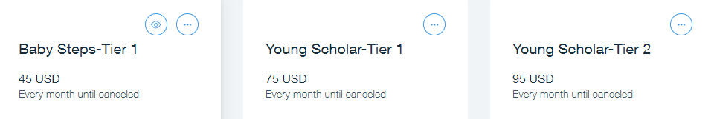
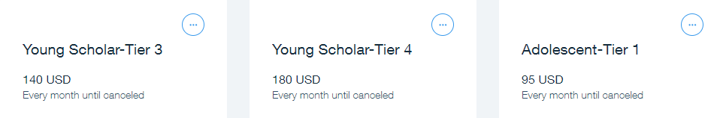
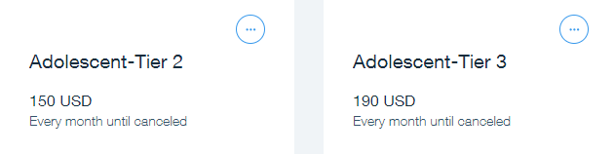
Weekly Schedule

Baby Steps Pre-K 3 - Kindergarten: Tier 1: 1 hr. weekly -- (2) 30 minutes group sessions
Young Scholar Grades 1-5: Tier 1: 1 hr weekly; Tier 2: 1.5 hr weekly; Tier 3: 2 hr weekly; Tier 4: 3 hr weekly
Adolescent Scholar Grades 6-8: Tier 1: 1 hr weekly; Tier 2: 2 hrs weekly; Tier 3: 2.5 hrs weekly

The following IXL packages may also be added to supplement tutoring services:

